**DAILY ONLINE ACTIVITIES SUMMARY**

|  |  |  |  |  |  |
| --- | --- | --- | --- | --- | --- |
| **Date:** | | **15/06/2020** | **Name:** | **JASLINE SHARON TAURO** | |
| **Sem & Sec** | | **4th sem, A Section** | **USN:** | **4AL18CS029** | |
| **Online Test Summary** | | | | | |
| **Subject** | **COMPLEX ANALYSIS, PROBABILITY AND STATISTICAL METHODS** | | | | |
| **Max. Marks** | **30** | | **Score** | **28** | |
| **Certification Course Summary** | | | | | |
| **Course** | | Application Developer | | | |
| **Certificate Provider** | | **AWS Educate** | **Duration** | | **3 hrs.** |
| **Coding Challenges** | | | | | |
| **Problem Statement:**   Write a Java program to check whether a given a binary tree is a valid binary search tree (BST) or not? | | | | | |
| **Status: EXECUTED** | | | | | |
| **Uploaded the report in GitHub** | | | **YES** | | |
| **If yes Repository name** | | | <https://github.com/jaslinesharontauro/JAVA_Prgms> | | |
| **Uploaded the report in slack** | | | **YES** | | |

Online Test Details: (Attach the snapshot and briefly write the report for the same)

Certification Course Details: (Attach the snapshot and briefly write the report for the same)

Coding Challenges Details: (Attach the snapshot and briefly write the report for the same)

ONLINE TEST DETAILS:

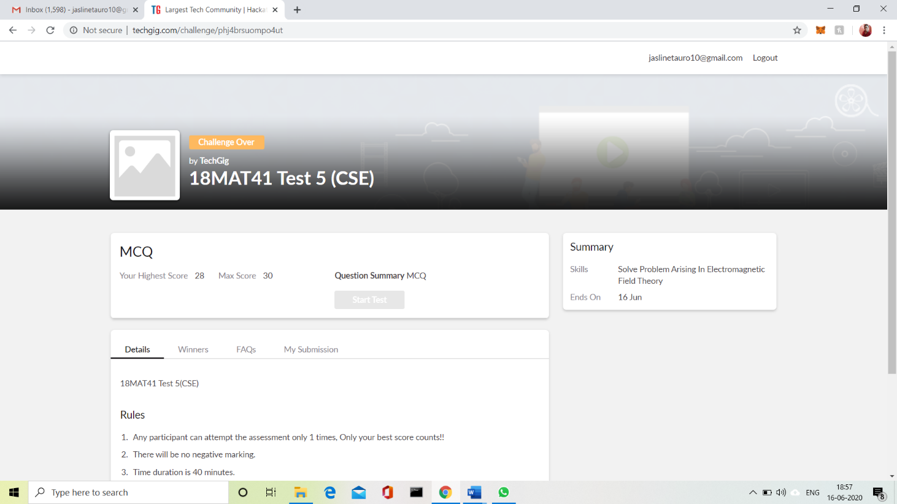Today we had assessment in the subject **COMPLEX ANALYSIS, PROBABILITY AND STATISTICAL METHODS. The test was conducted on the first module of this subject. The test comprised of total 15 questions of TWO marks each, out of which I scored 28.**

CERTIFICATION COURSE DETAILS:

Today I have continued the course “Application Developer” by AWS Educate. In this course today I learnt about ‘**Software** Development: Web, Mobile and **Gaming**’. In this module I learnt about web development and Mobiles for Startups and Gaming. I have also successfully completed the Assessment regarding this module.

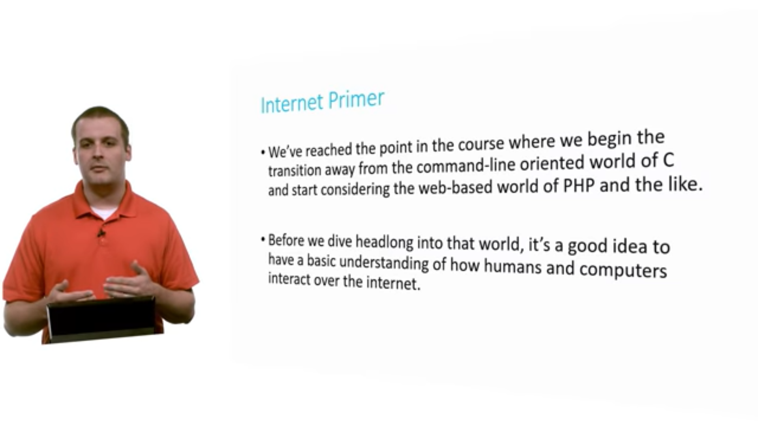

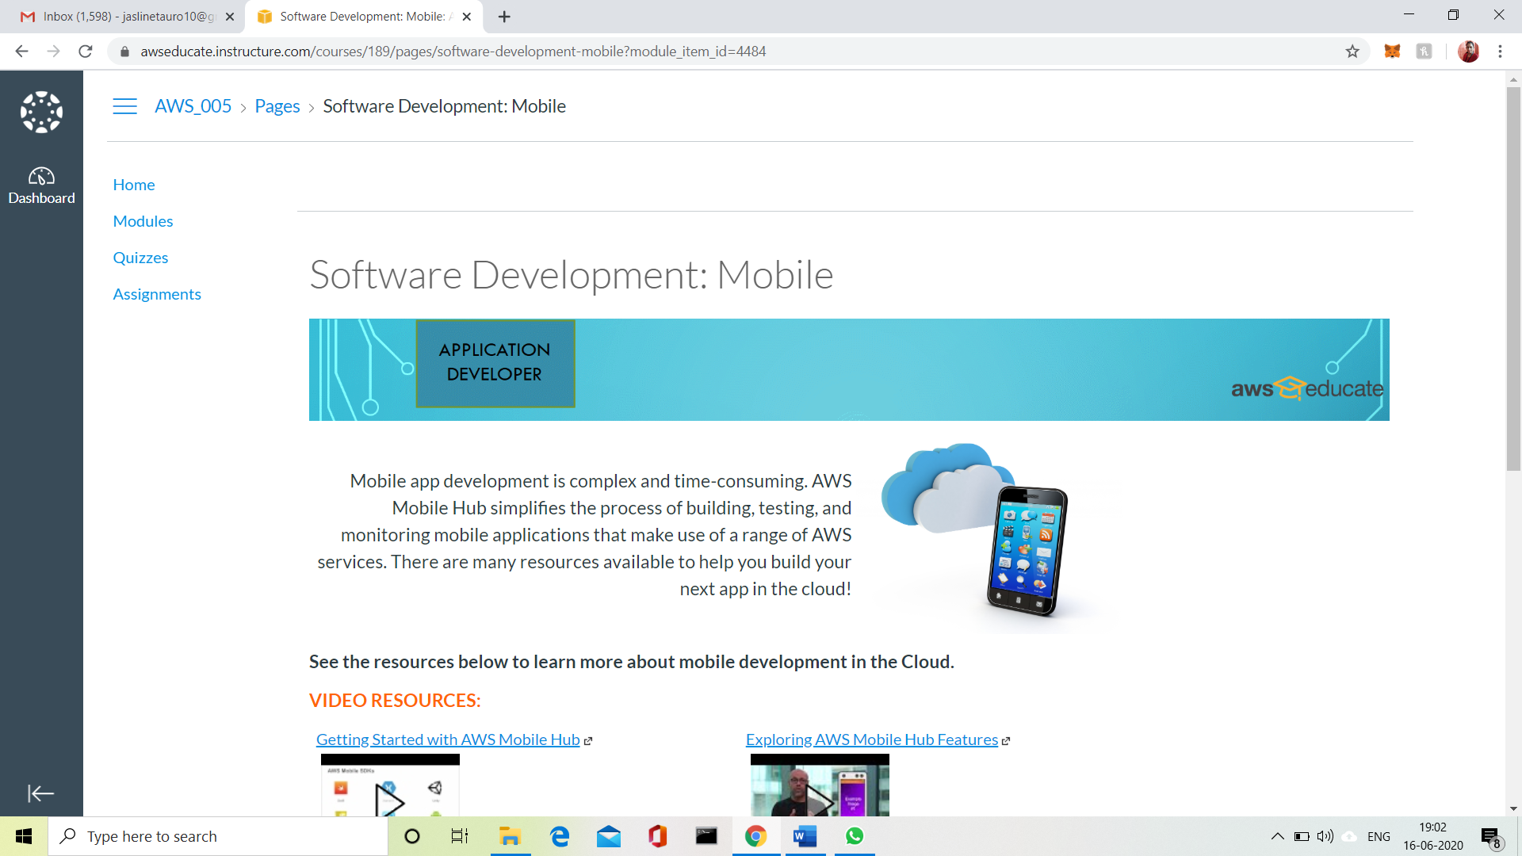

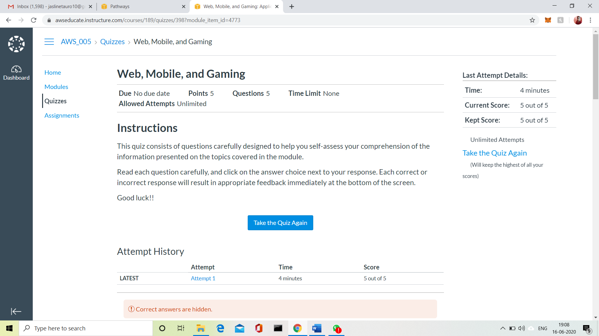

3.CODING CHALLENGES:

Problem Statement 1:

Write a Java program to check whether a given a binary tree is a valid binary search tree (BST) or not?

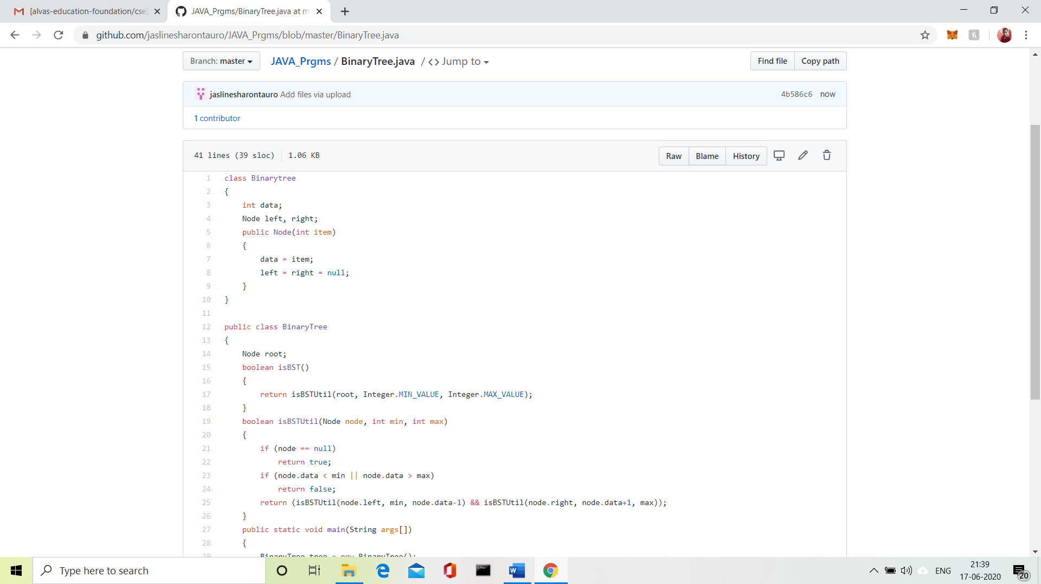

Solution uploaded in GitHub.